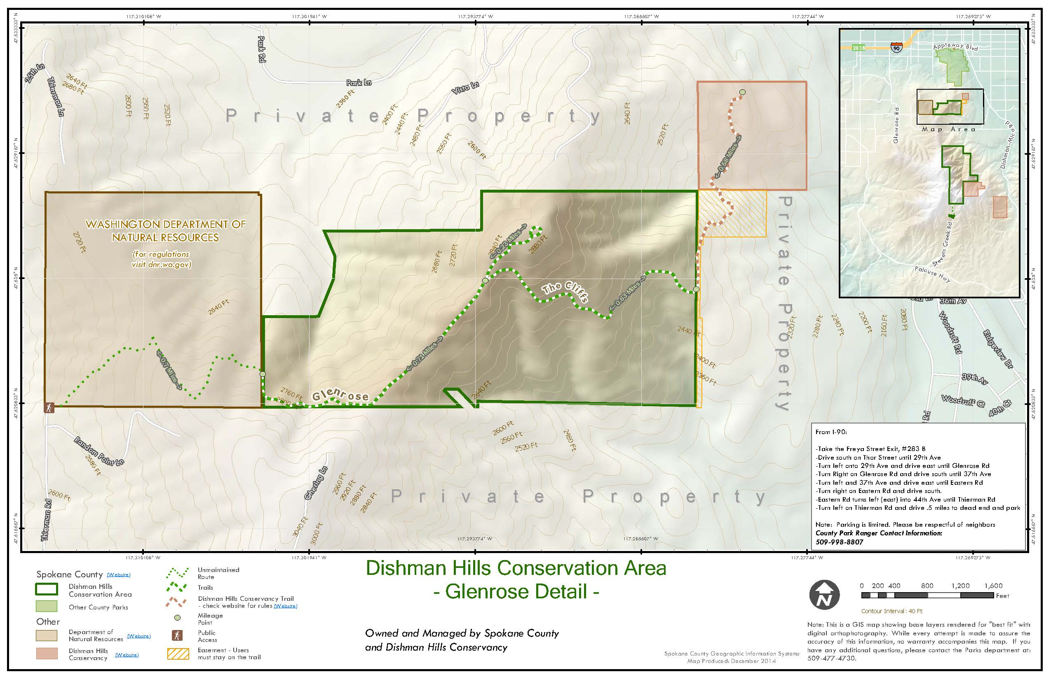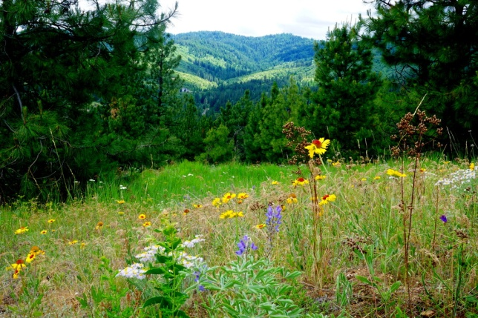

Come to the Glenrose Association Meeting at 6:30 p.m. on Monday, August 8th.

3700 S Thierman Rd.

# Dishman Hills Conservancy

# &

**Glenrose Association**

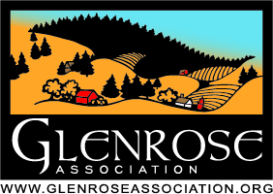

Trail map to the Glenrose Unit of the Dishman Hills.

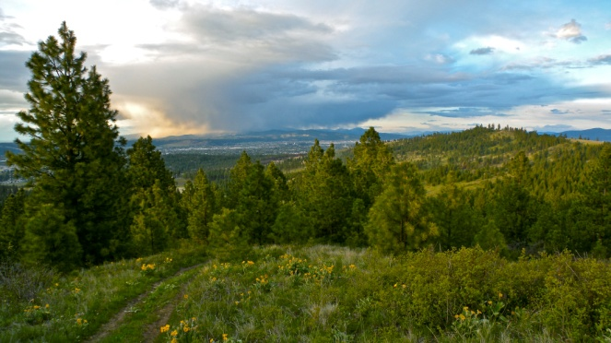

Help us conserve and connect the wild heart of Spokane!



View east over Conservation Area.

**GlenroseAssocation.org**

**DishmanHills.org**

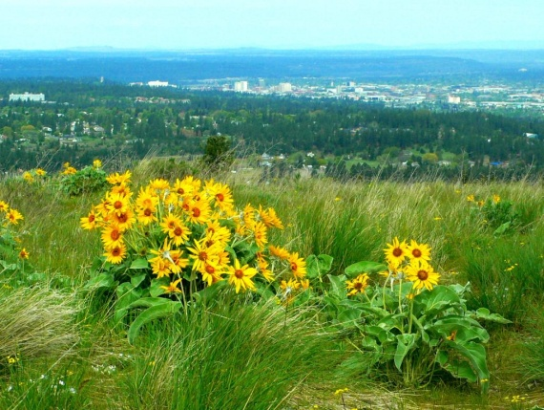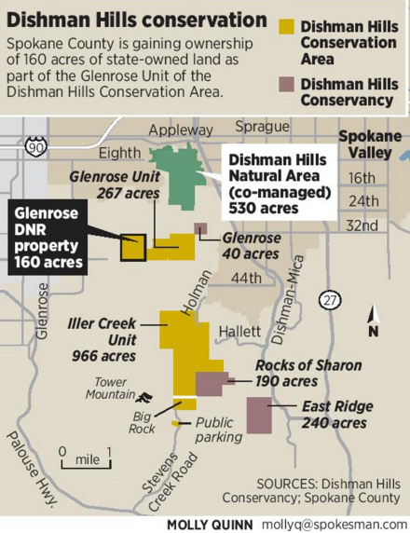

**THE GLENROSE ASSOCIATION**

**22 Years Dedicated to the Preservation of the Rural Character of Glenrose!**

## 72 Combined Years!

The DHC is celebrating 50 years of land conservation. The Glenrose 160 acres is the latest addition to the 2700-acre Dishman Hills Conservation Area. The Glenrose 160 was transferred earlier this year from Washington State to Spokane County after a successful campaign by DHC and the Glenrose Association. This newly protected area provides a critical recreational access to about 500 acres of the Dishman Hills.

Location map showing the Dishman Hills Conservation Areas.

### Trail Head Collaboration

There will be a trail head in Glenrose – most likely at the north end of Thierman Road (3700 S Thierman Rd.). The DHC and TGA are looking for community input during the important design phase of the trail head. We have reached out to Spokane County Parks requesting a collaborative planning process that will include trail head location and design, parking, trail signs, and security. We need to provide a fun and safe access to the Dishman Hills for hikers and equestrians while respecting the privacy of neighbors in the area.

Until the process with the county begins, we want to start the conversation with a site visit on Monday, August 8th at 6:30 p.m. at 3700 S Thierman Rd. We will review any and all the issues of concern from the Glenrose Community.

**You are invited to a Site Visit!**

When: Monday, August 8th 6:30 p.m.

Where: 3700 S Thierman Rd.

What: Looking at possible parking lot sites and designs for trail head

View over Glenrose and Spokane from Conservation Area

**Dishman Hills Conservancy**

Jeff Lambert, Executive Director

PO Box 8536, Spokane, WA 99203

Phone: (509) 999-5100

[ed@dishmanhills.org](mailto:ed@dishmanhills.org)

**The Glenrose Association**

Bob Hyslop, President

PO Box 30202, Spokane, WA 99223

Phone: (509)475-2448

[rchyslop@msn.com](mailto:rchyslop@msn.com)

**Contact us!**